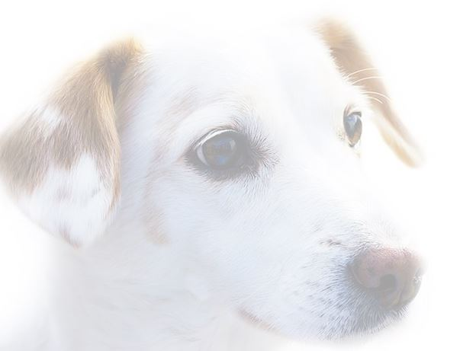

A Dog Blessing
Knowing God is love and my beloved dog loves me more than itself I’m humbled to know the Divine is in my life as my four legged companion. No matter what I do or whatever happens in my outside world, my furry friend unconditionally loves me for who I am on the inside. When the tears are licked from my cheeks, sadness is gone. The presence of my dog, who is unique and individual from all other animals of the world, is a gift of nature that sooths my soul, bringing healing comfort to all my concerns.
My beloved friend continues to walk this world in joy and grace, while divinely guided, protected and blessed. The innate Intelligence of the universe finds Its natural expression through my trusted companion. Our evolving soul agreement brings us together and all that is necessary for this reciprocal relationship of loyalty and dedication is always provided. My dog continues to experience perfect health, knowing how to heal when in pain. I am in tune with my four legged friend’s spirit. I find the space to allow that spirit to run and remember its wild nature continuing to be wise in my choices as leader of the pack.
Grateful for our relationship and the times we share in this world, knowing love transcends time and space allowing those memories to always live in my heart keeping us connected. My life is richer because of the love experience with my dog. I am filled with appreciation for the carefree lessons in the joy of being fully present in happiness. My beloved four legged companion continues to be blessed, safe and healthy in its fun filled run through life!
By Reverend Christian Sorensen From The Seaside Center for Spiritual Living

